Hermes Transport
Courier Services Management and Tracking Platform

User Guide



Table of Contents

Intro 3
Landing Page 3
Login Page 4
Dashboard Page 5
Parcels Page 8
Courier Page 14
Financial Reports 19
Staff Page 23
Settings Page 26

Intro

This guide has been created to help acclimate to all the processes and actions available within the Hermes platform system. This guide is intended to be used when first navigating the system and learning it.

This guide will go over each of the pages within the Hermes Platform system and cover all the actions available on those pages. These sections will be accompanied by pictures of the system with the parts being referred to surrounded by a red box to help indicate what each section is referring to when going over the different sections of the system.

Landing Page

The landing page is the first part of the system that a user will encounter and is where the user of the system will be able to login. It contains a short blurb about the system as well as its logo. To log into the system, the user must click on the login button in the top right of the screen.

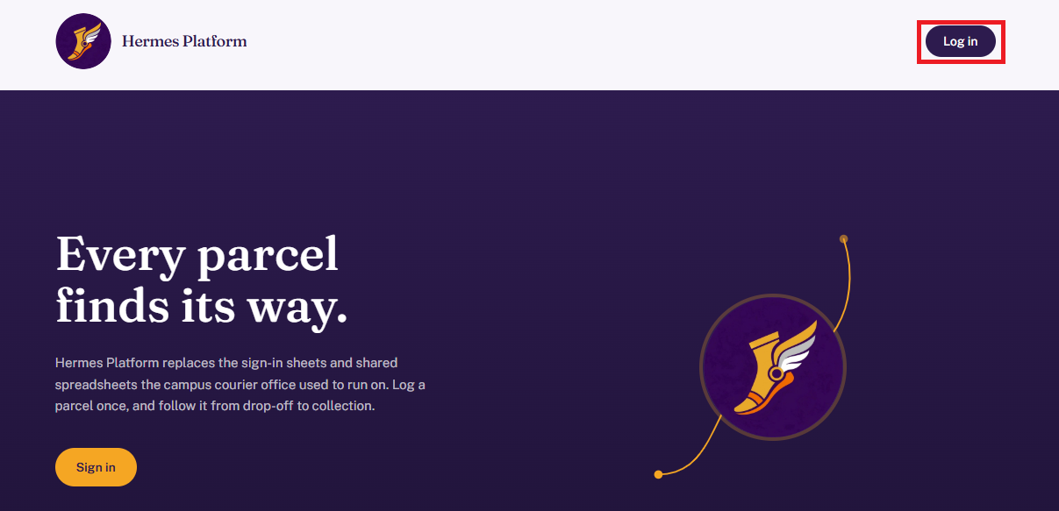
Once the login button has been clicked the login page will open

Login Page

In the login page you will enter your email address, for this guide the assumption is that the user is the default admin. In this case the email to be used is ‘admin@gmail.com’
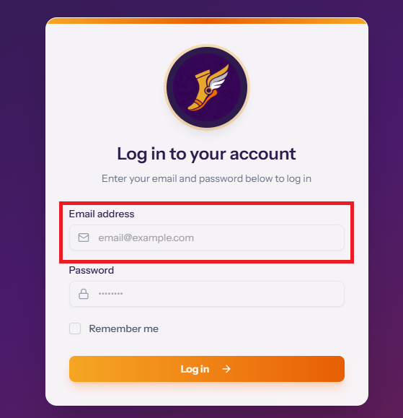
Afterwards the user will then enter their password in, for the default admin account the password is admin1234
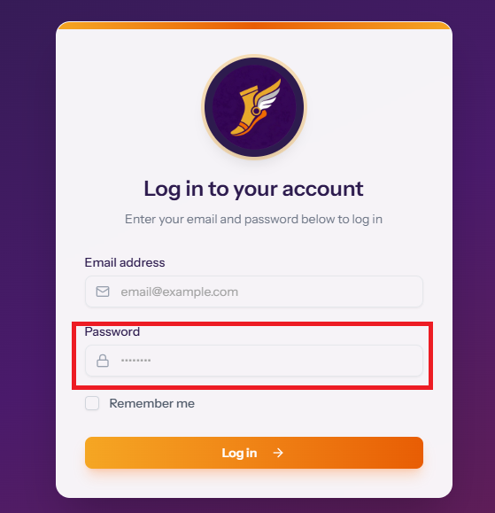
Once both sections have been filled in the user can click on the log in button at the bottom of the page. This will then take the user to the dashboard Page

Dashboard Page

The dashboard acts as a quick glance at the current state of parcels showing how many are in the current system, how many have been collected and how many must still be collected.
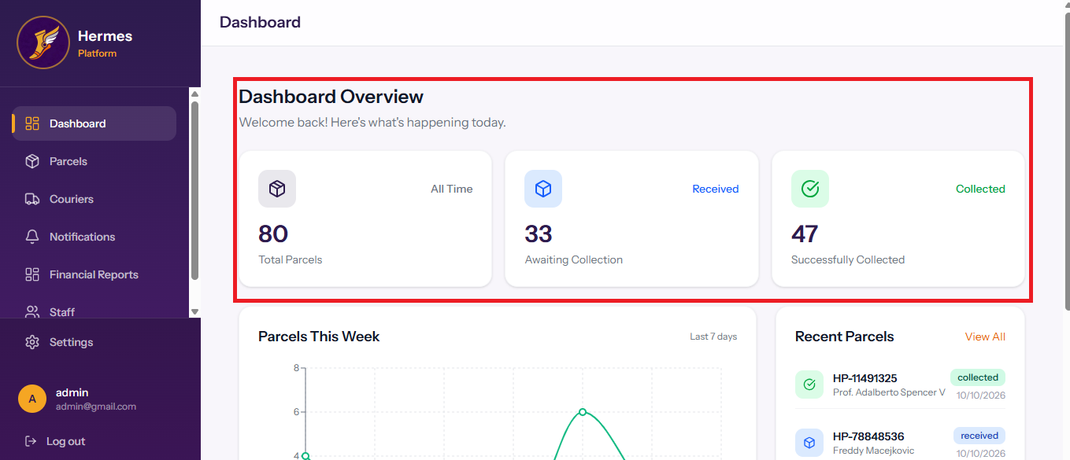
Beneath this section you will find a graph indicating the movement of parcels in the system, this showing both parcels that have already been collected and those still located within the business. To the right of the graph you will see the most recently added parcels in the system.
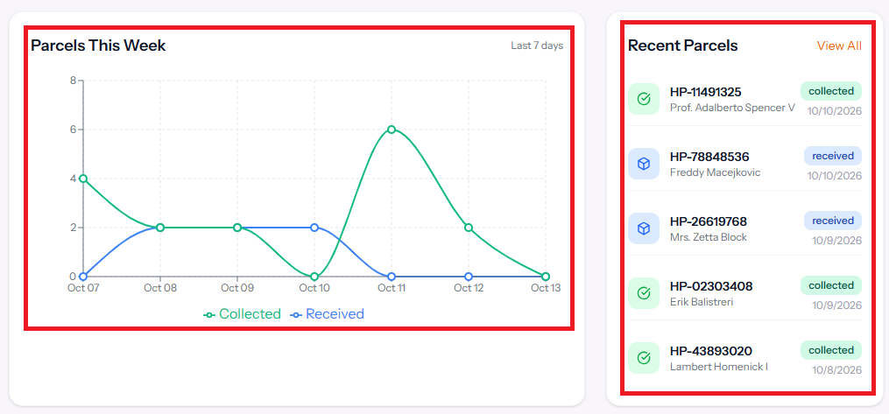
To navigate to any other page on the Hermes Platform the user must click on the desired page’s name located to the very right of the screen. Admin users will have every page available, these being Parcels, Couriers, Notifications, Financial Reports and Finally staff. Non-admin staff users will have access to the Parcels and Notifications pages.
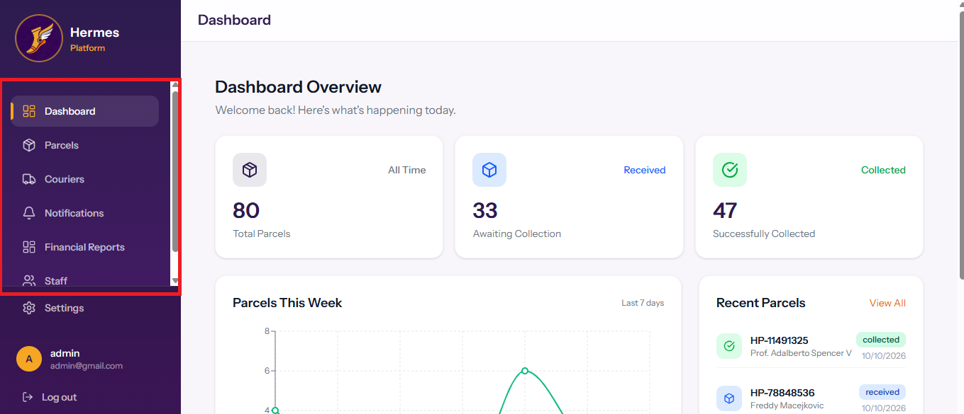
In the bottom left of every page the user will be able to see the account they have logged in with as well as be able to click on a settings button to configure their own preferences. Beneath the user’s account you will have the option to log out.
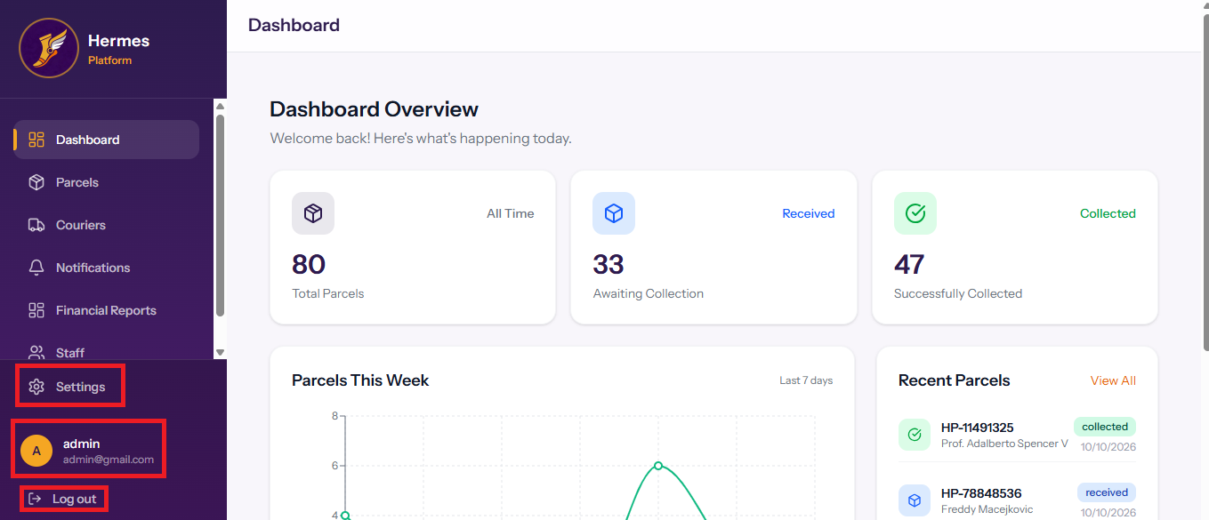

This guide will now move through the different pages available in the Hermes Platform system starting with parcels and moving through all of them till the settings page.

Parcels Page

The parcels page shows the same information at the top of its page that is found on the dashboard page.
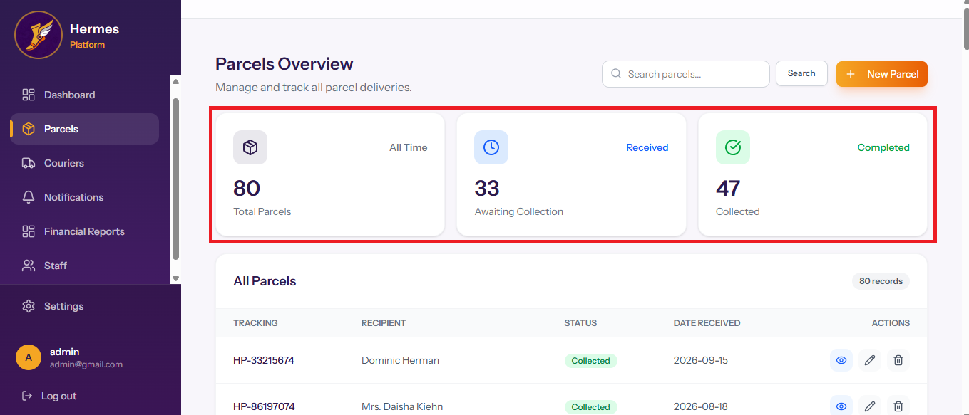
Above this section the user can find the search bar where they are able to enter details of parcels to filter the page for a particular parcel. After entering the value you wish to search for the user must click on the ‘search’ button. Next to the search bar, the user can click on the ‘New Parcel’ button to create a new parcel
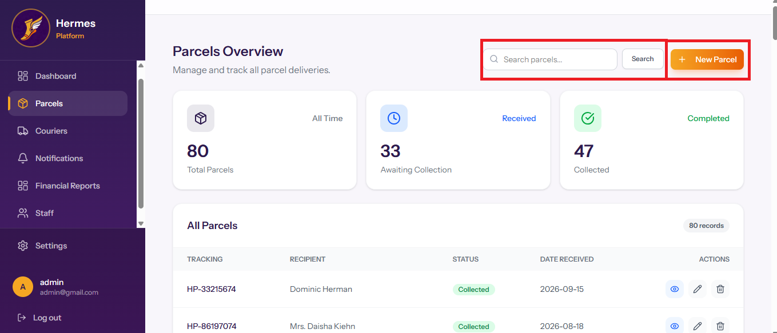
If the user clicks on ‘New Parcel’ a form is open on the page. The first thing available on this page is the barcode scanner which lets the user use their own laptop’s camera or desktop’s web camera to scan the parcel.
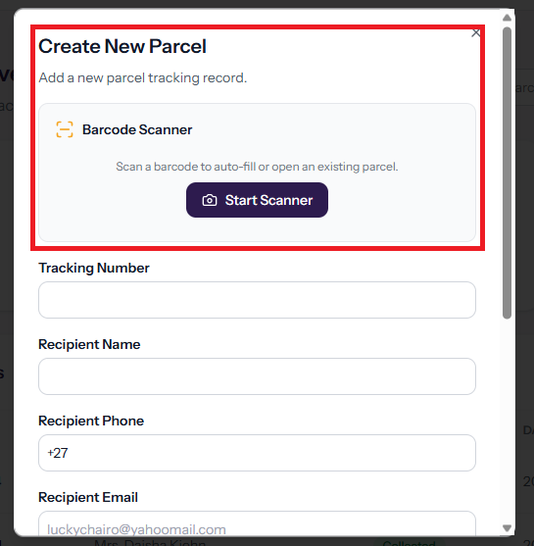
To use this feature the user must click on the ‘Start Scanner’ button which opens a view that appears in the image bellow
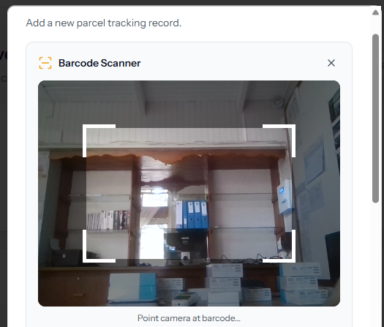
Beneath the barcode scanner the user can enter the tracking number of the parcel and the recipient’s name
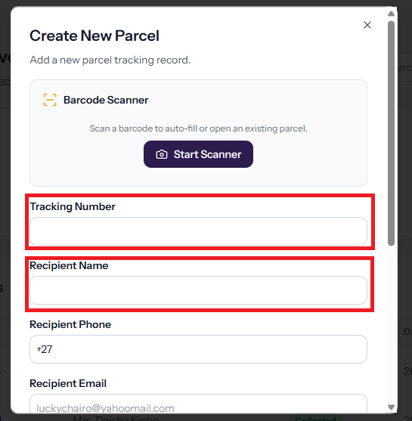
A usb barcode scanner can also be used, in testing a Mindeo MD2000AT was used. To use it properly click in the field you wish for the data to enter once you have selected it, pick up your barcode scanner and scan the relevant bar code for it to enter the data into the field. Below is a picture of the bar code scanner.

Beneath this section the recipient’s phone and email can be entered. These two values must be entered if the user wishes for the system to send the automated messages. Beneath the recipient’s email there is a box that can be ticked so that an email is also sent to that client once the parcel has been created.
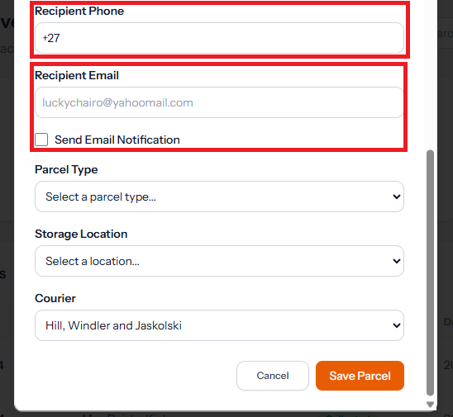
Finally the user can select from a drop down what type of parcel it is and where the parcel will be stored as well as the courier who delivered the parcel.
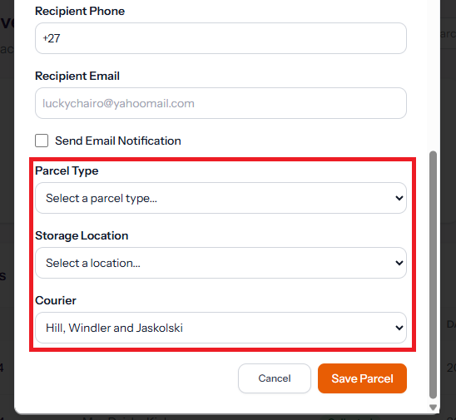
At the bottom of the form the user can either cancel the creation of the new parcel and click ‘Save Parcel’ to add the parcel to the system.
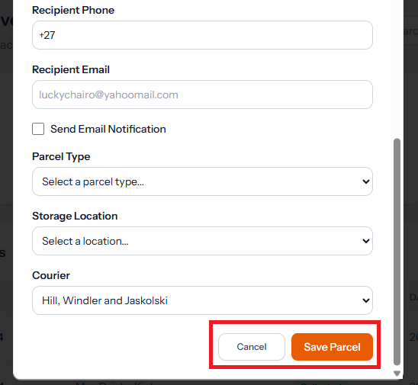
After either canceling or saving the parcel the user will be placed back on the parcel page. Beneath the summary of all parcels the user may individually view each record of parcels beneath each other.
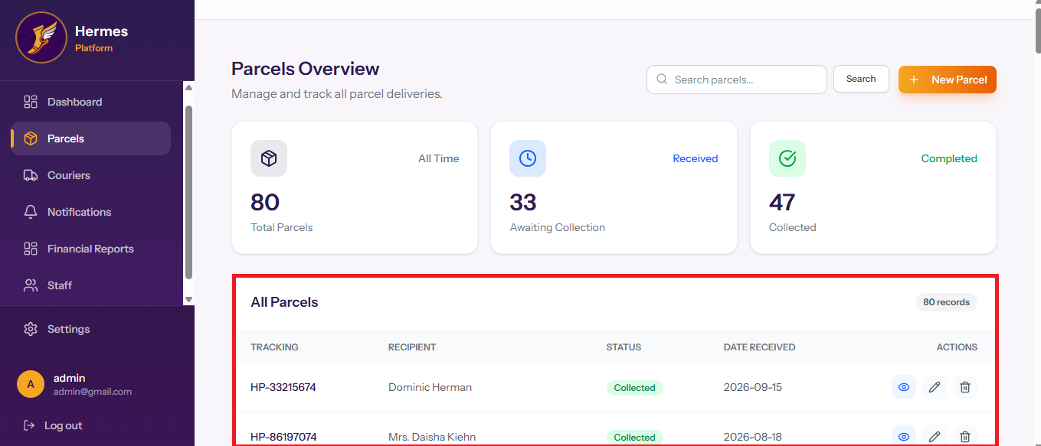
On each individual parcel there a three buttons located to the left of the record, these three buttons in order from left to right let the user, ‘view the details of the parcel’, ‘edit the parcel’ by bringing up a new window that looks like the ‘New Parcel’ Page button with each value already filled in. The final button is ‘Delete’ which will remove the record from the system
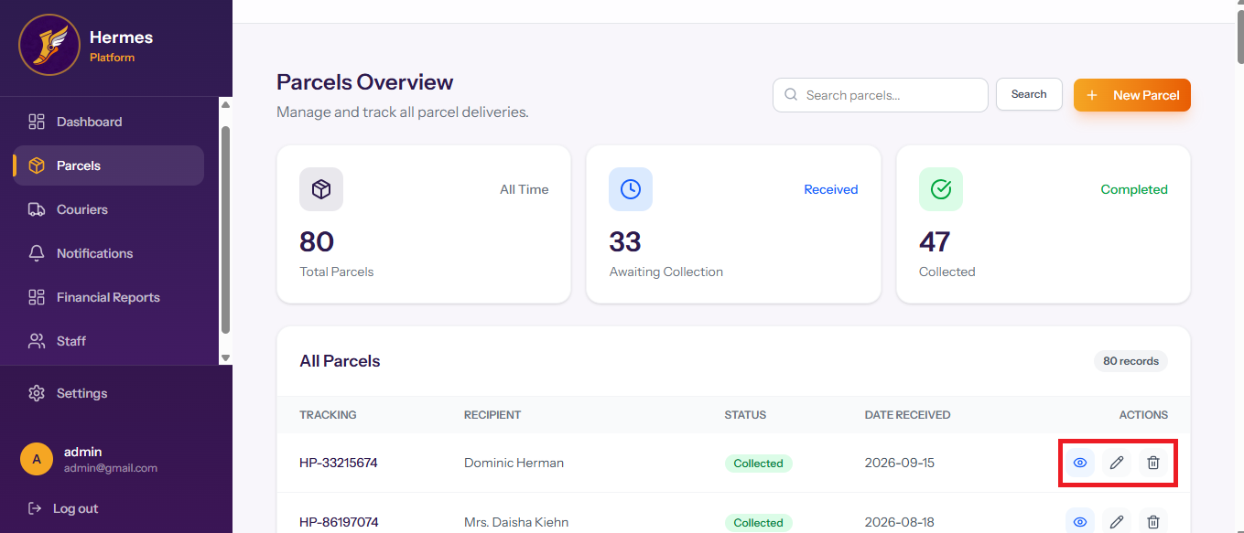
If the user clicks on the ‘view parcel' button it will bring up a new page that shows the details of the parcel in a more pleasing format with its barcode included.
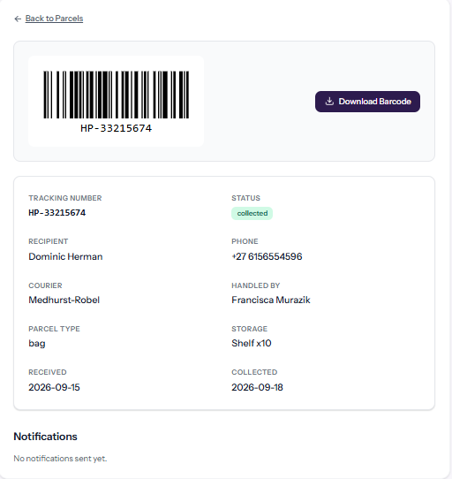
This guide will now move onto the courier page

Courier Page

The courier page shows the users all couriers who have delivered items to the business as well as showing how many parcels are linked to each courier.
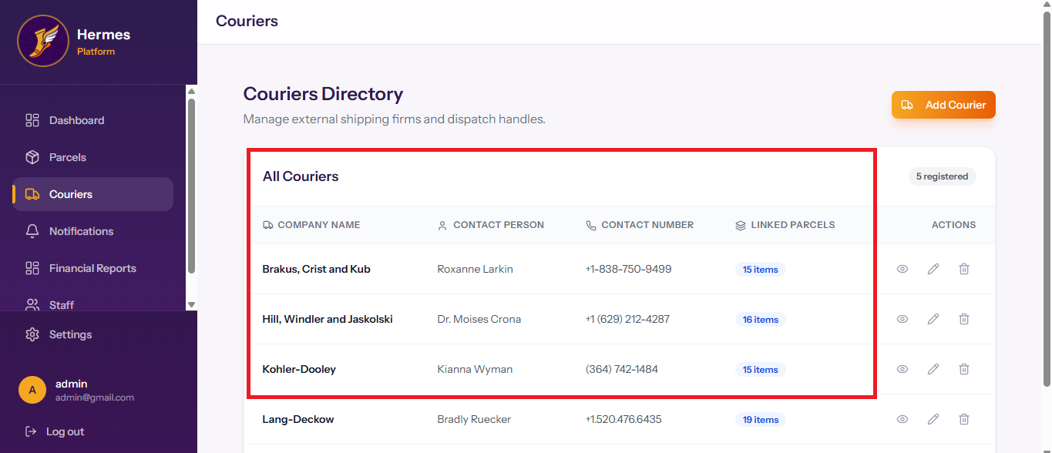
The same three buttons exist for couriers as they did for parcels, these being ‘View courier’, ‘Edit courier’ and ‘Delete Courier’
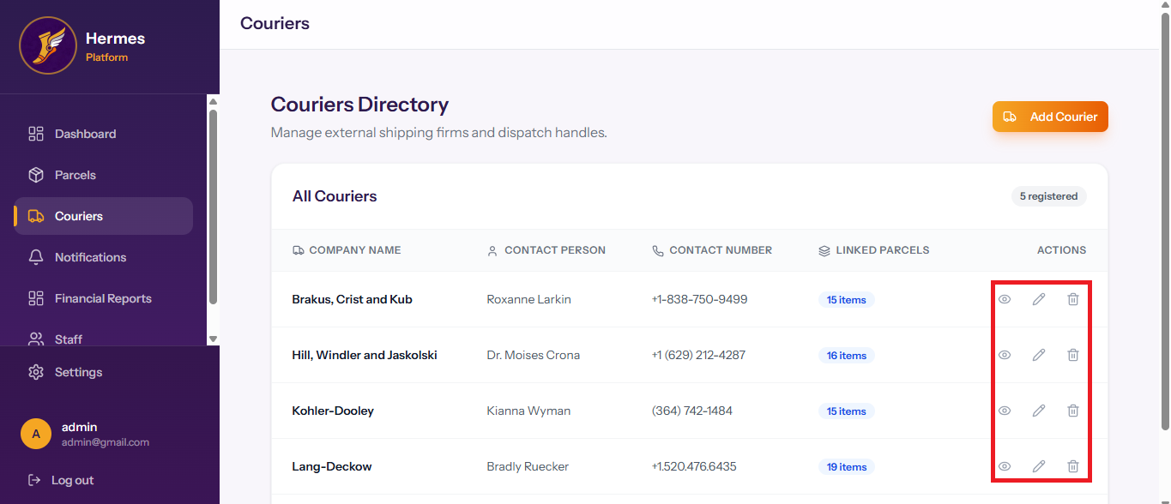
To add a new courier the user must click on the ‘Add Courier’ button at the top right of the page
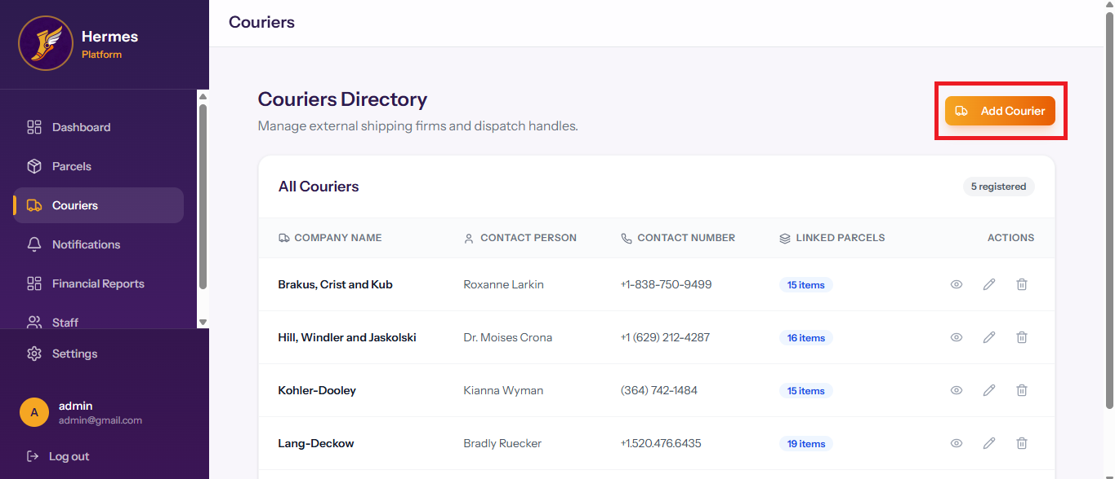
Once the ‘Add Courier’ button has be clicked a new form will be open on the user’s screen where details of the courier can be added such as their name, description, Contact person, Contact number, email and website
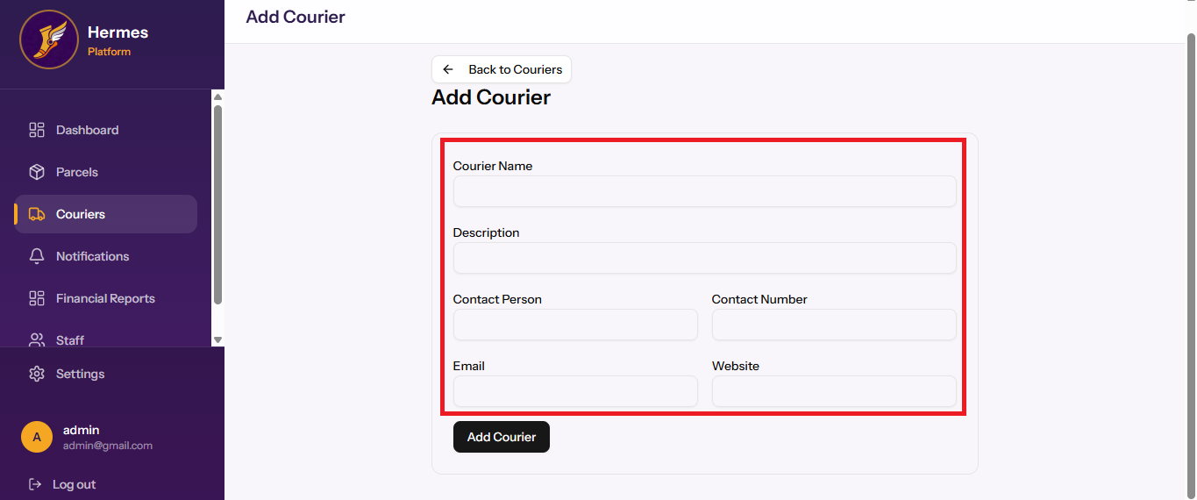
Once all details have been filled in the user must click on the ‘Add Courier’ at the bottom middle of the screen. If the user wishes to cancel the entering of a new courier they can click on the ‘Back to Couriers’ button at the top middle of the screen.
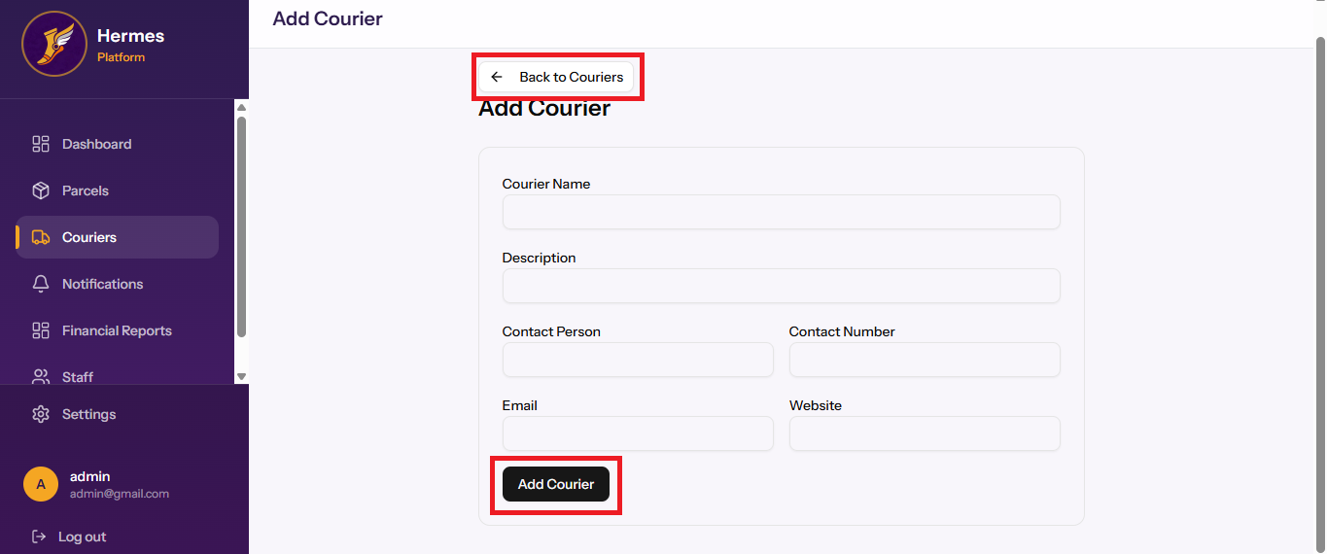
If you click on the ‘View Courier’ button the details of the courier will be visible as well as the names of recipients who used this courier
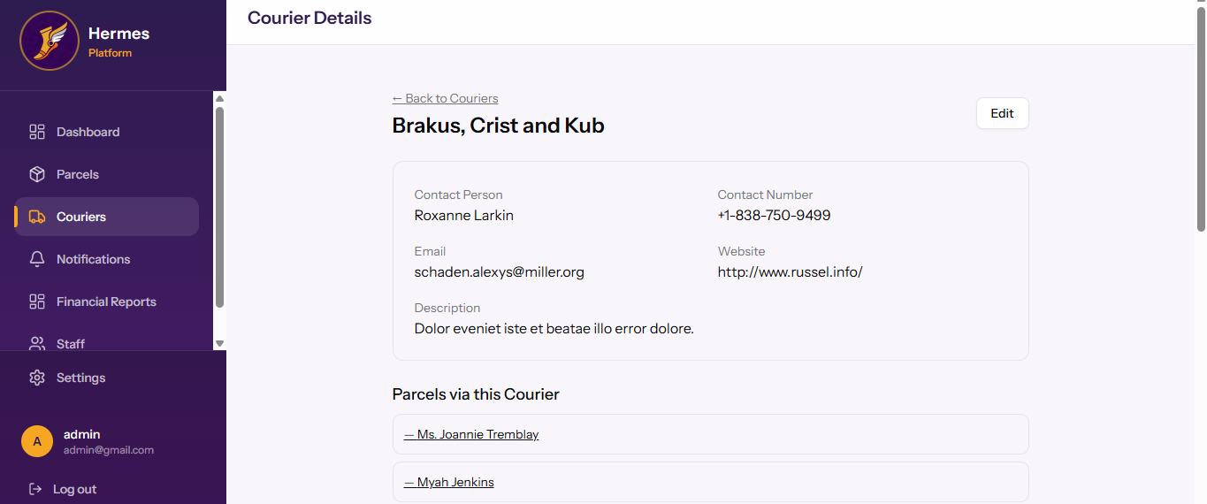

Notifications Page

The notification page shows all notifications sent for each parcel and the method of communication used, the message sent and the day to collect as well as the status of whether the parcel has been collected or not
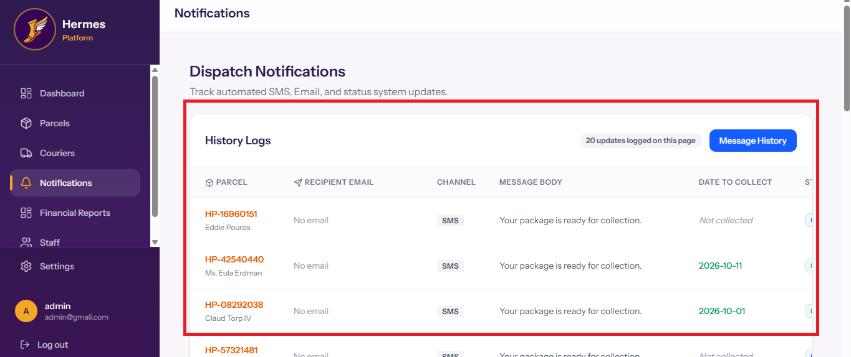
The user can scroll the message until the far right where they can click on a button to view the message in more detail.
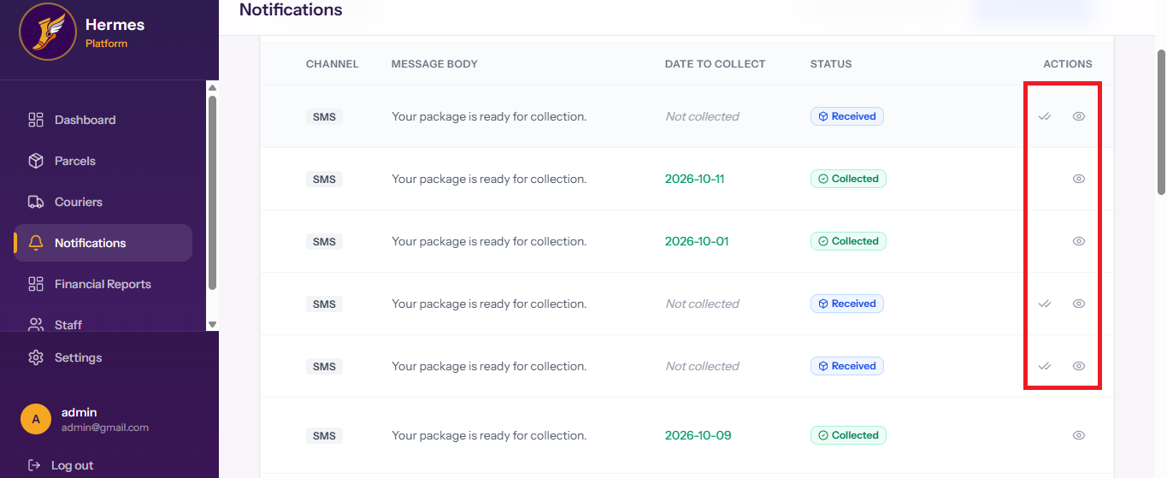
This brings up a more detailed view of the notification
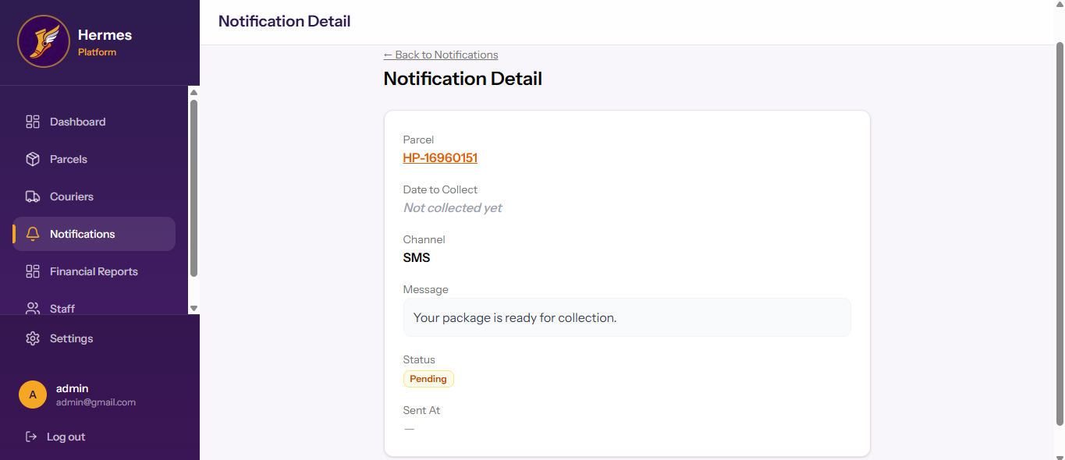
Back on the main Notifications page the user may view older messages in the system by click on ‘Message History’ in the top right of the page.
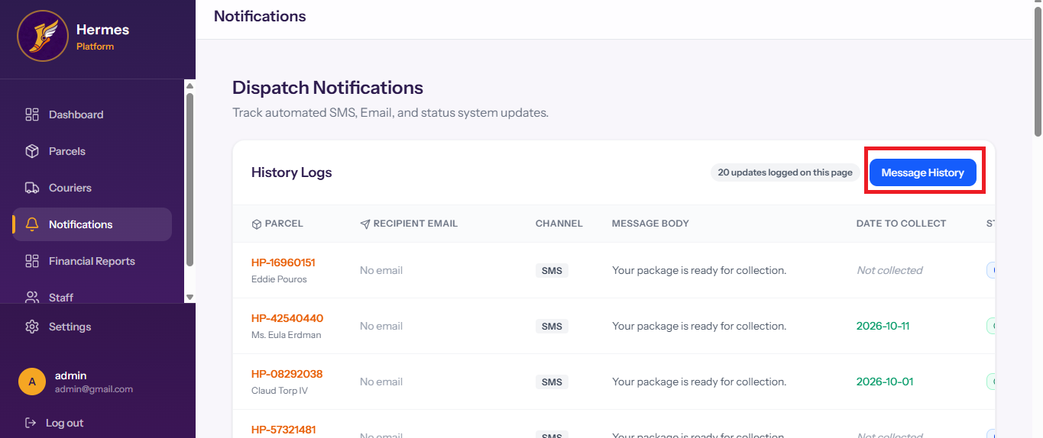
This opens a new page showing older messages
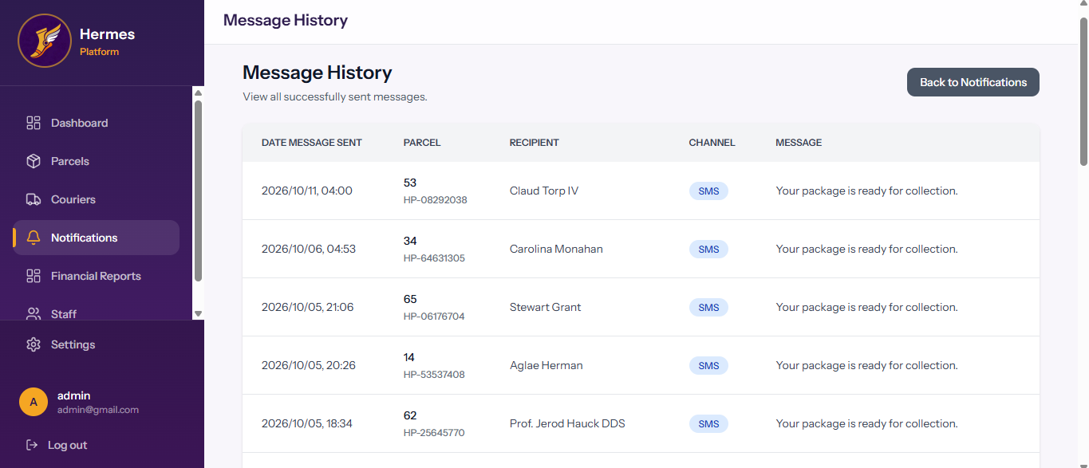

Financial Reports

On the financial reports page the user is able to generate a financial report that allows the user to review the amount of revenue collected over a certain period. The options for the time periods are daily, Monthly, Quarterly, Bi-Annual, Annually and the ability to set a custom range. The user must simply click on the button of whichever time period the want
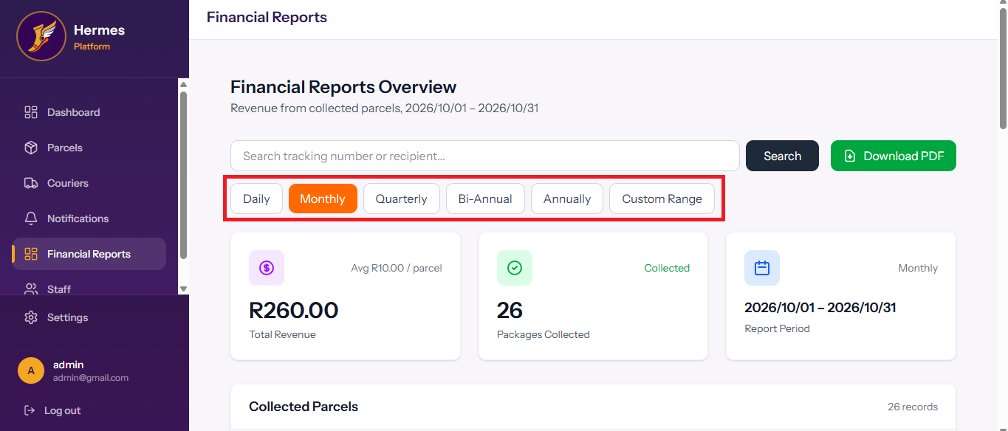
If the custom range is click a new section is opened underneath the range selection and to dates can be entered, the first for the starting date and the second for the end date. Once both have been entered the user must click on apply
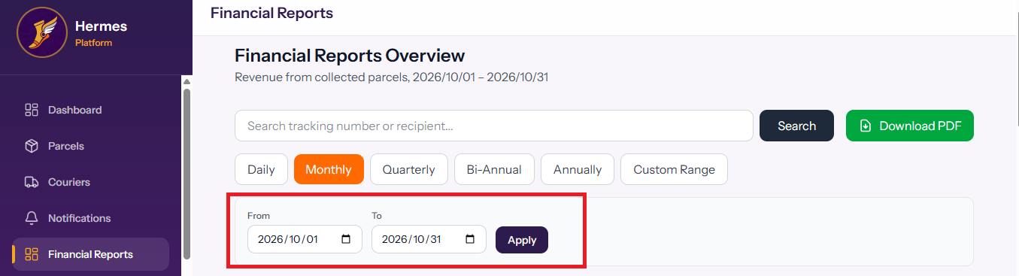
Once a range has been selected the page will show all parcels that are applicable to the range selected, How many parcels fall into that range the revenue acquired for them
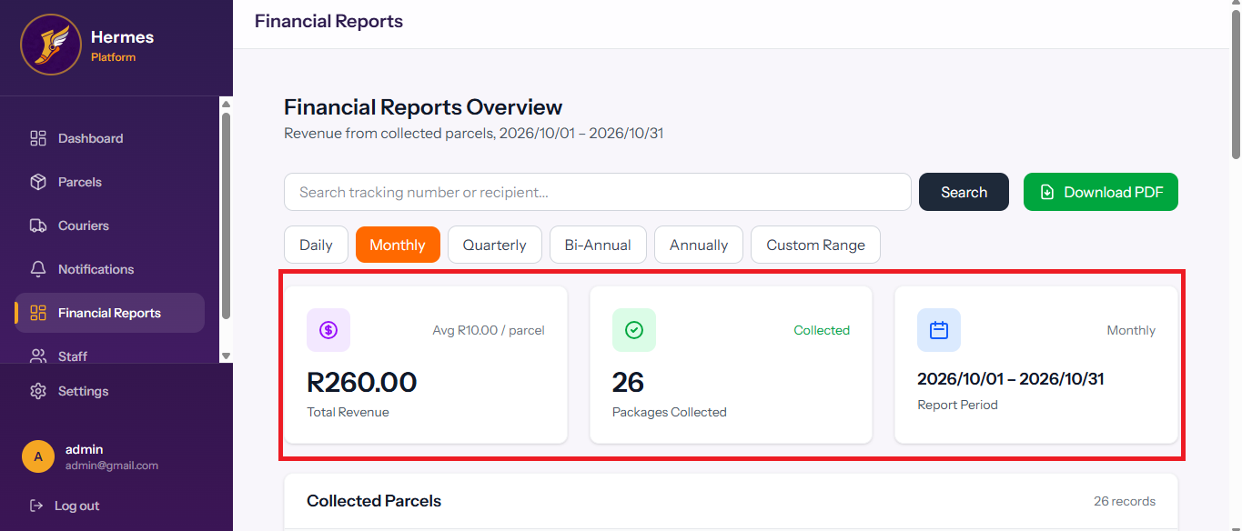
Beneath these boxes the parcels are listed individually that apply to this report
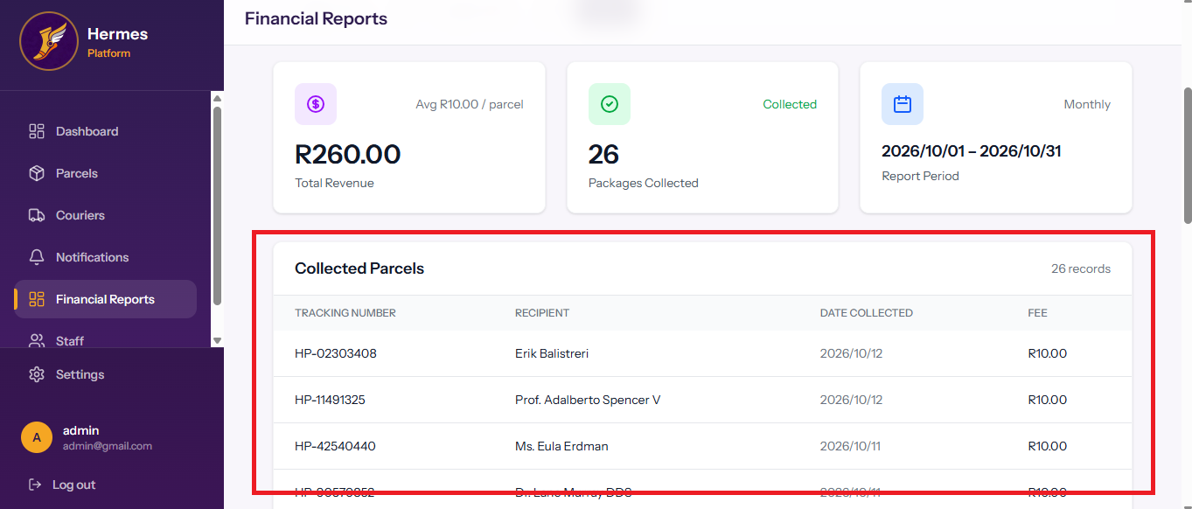
Once the range has been selected the user may click on the ‘Download PDF’ button to create a PDF of the report
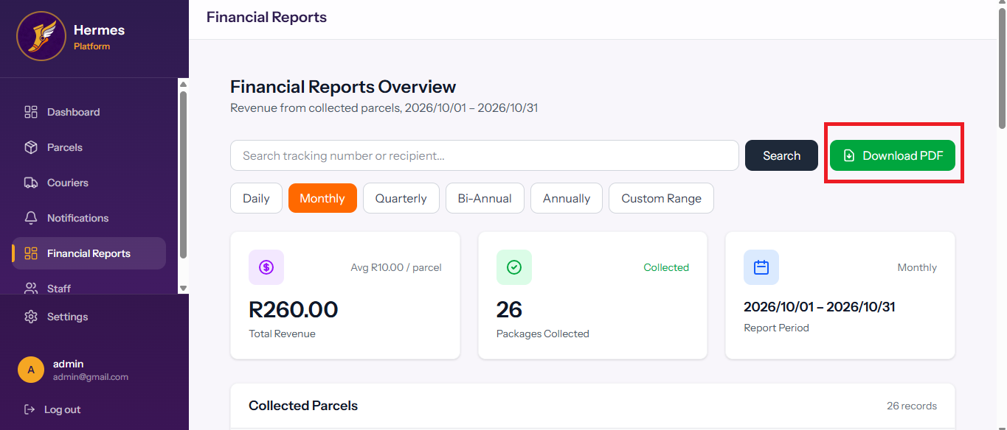
This generates a report which looks like the image bellow
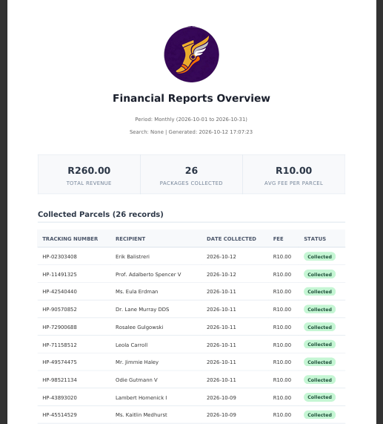

Staff Page

The staff page allows the user to view all staff member accounts that have access to the system and what their level of privilege is
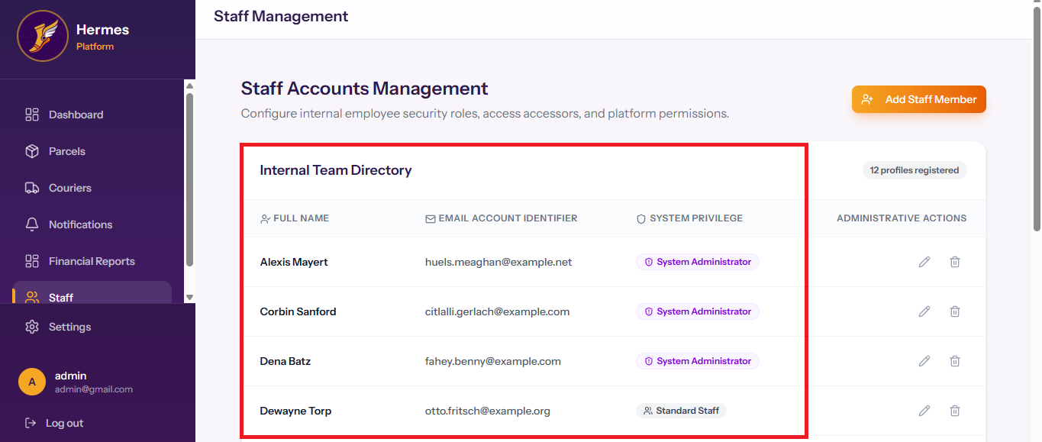

At the far left of each record the user is able to edit the details such as email and password of a staff member or delete the staff member from the system or the user may delete the account from the system
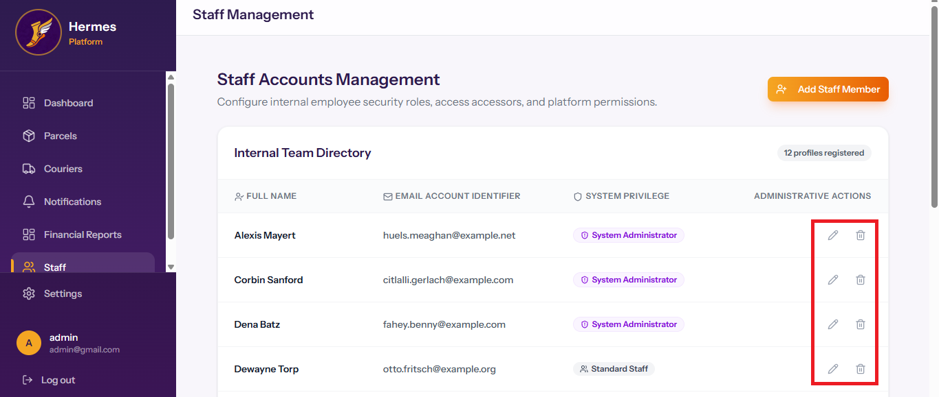
To add a new staff member the user must click of the ‘Add Staff Member’ at the top right of the page
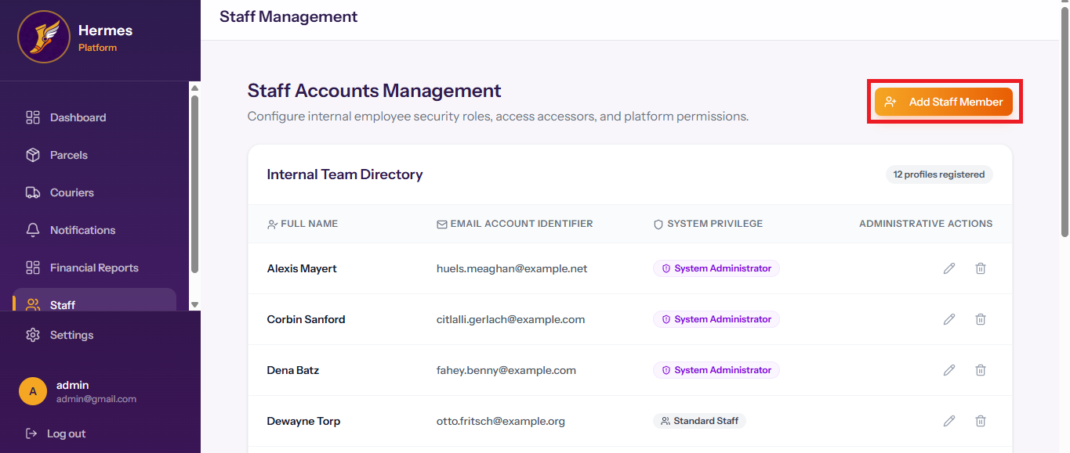

This will bring up a new window where the user can enter the details of the staff member such as first name, surname, email account, System role and their password. System role is a drop down between the account being and administrator or standard staff
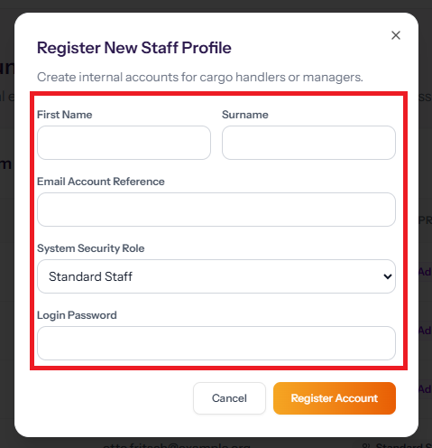
Once all these details have been entered the user must then click on the ‘Register Account’ button. If the user wishes to cancel the process they can also click on the cancel button.
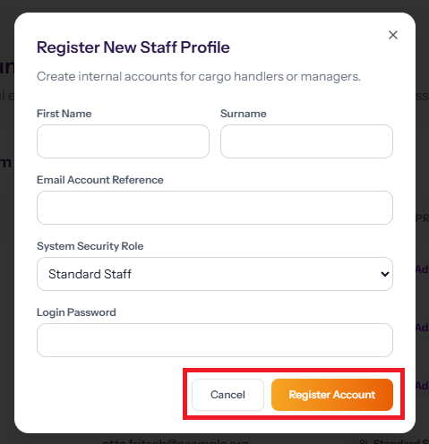

Settings Page

If you click on the settings button it will open a new page on your profile which shows your own personal account and allows you to edit your password.
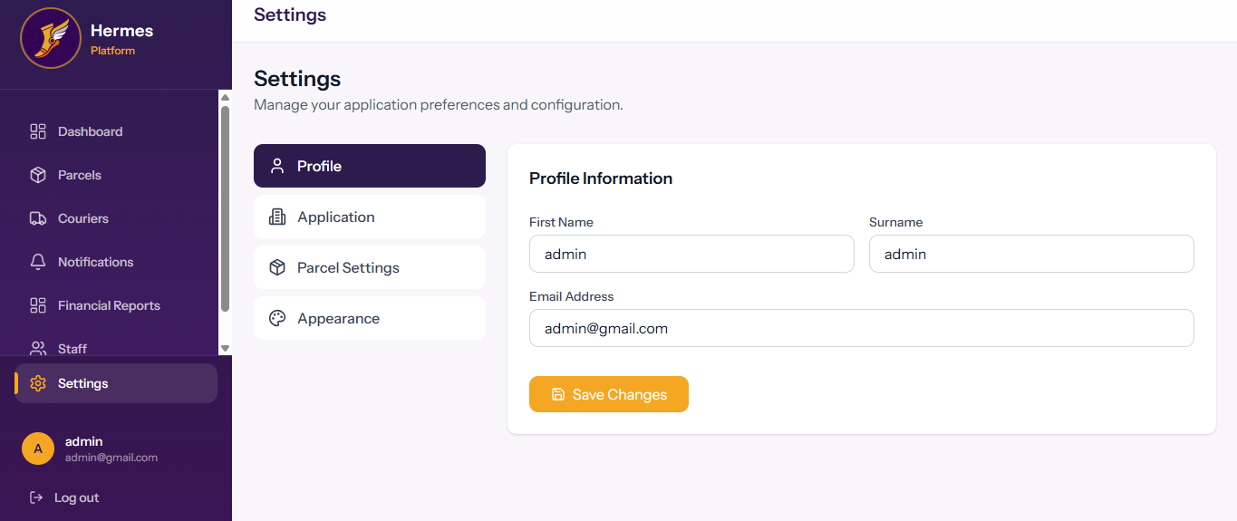

For the user to access other settings, they can select the settings they wish to change by clicking on the desired setting button in a new menu of the left side of the screen
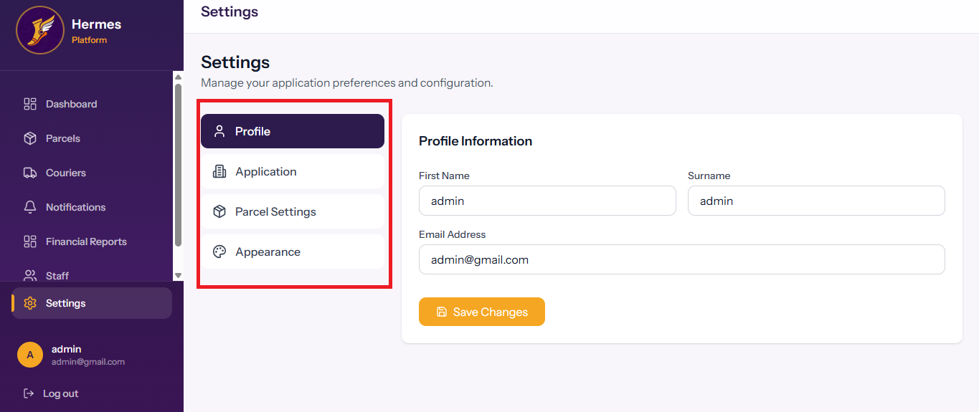
The user can then access the application settings page by clicking on the new menu found on the left, this allows the user to enter the details of their own company into the system.
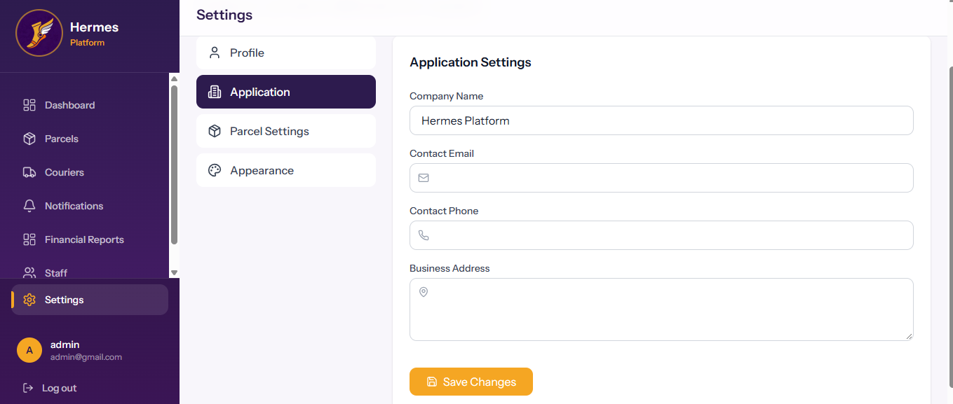

The Parcel setting page allows the user to edit the auto generated number for each parcel.
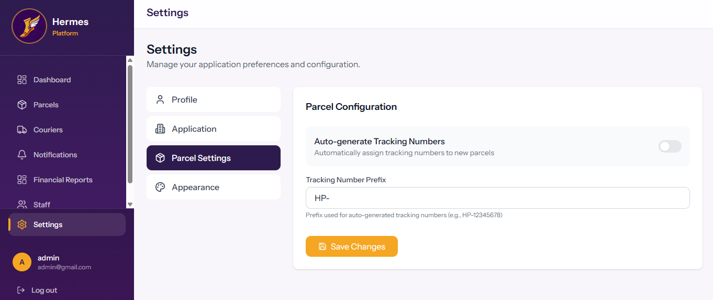
The appearance section allows the user to update the theme of the system
